Resources- Youtube (CodeWithHarry, Saurabh Shukla)

James Gosling
Sun Microsystems, Oracle
Java is platform independent
Source code after compilation-> Byte code, Byte code is interpreted later.
public static void main - static (so that we can treat main as a function and we won’t have to call it through object), public is access specifier
Each class is in a separate file.
Class name - PascalCaseConvention
Function name- camelCaseConvention
JDK(Java Development Kit) - development tools
JRE(Java Runtime Environment)- to execute java programs, contains JVM and java package classes

Variable name- letters, numbers, $, _

Anatomy of a Java program-
Documentation section- Suggested
Package statements- Optional
Import statements- Optional
Interface statements- Optional
Class definitions- Optional
Main method class and main method definition- Essential

Data types-> Primitive (Intrinsic), Non-primitive (derived)

Primitive data types-
Java is statically typed. (Variables must be declared before use!)
byte - 1 byte, -128 to 127, default value=0
short- 2 bytes, default value=0
int- 4 bytes, default value=0
float- 4 bytes, default value=0.0f
long- 8 bytes, default value=0
char- 2 bytes, supports unicode, value range(0 to 65535 ( 2^16-1) ),
default value= \u0000
boolean - value can be true or false, default value= false, size depends on JVM

JVM depends on the OS. JVM has to be installed. JVM is platform dependent.
Hello.java => Hello.class (after compilation)
Hello.class => JVM with interpreter (Just-in-time compiler ) => OS

Primitive data types- 1) Integral- byte, short, int, long
2) Float- float, double (by default double)
3) Char-
4) Boolean-

byte age = 34;
int age2 = 56;
short age3 = 87;
long ageDino = 5666666666666L; // L or l at the end
char ch = 'A';
float f1 = 5.6f;
// write f at the end for float (otherwise it becomes double by default and gives error)
double d1 = 4.66; // double by default
boolean a = true;
System.out.print(age);
String str = "Harry";
System.out.println(str);

String str= “Harry”;

Getting user input
The Scanner class of java.util package is used to take input from the user's keyboard.

import java.util.Scanner; // Importing the Scanner class
Scanner sc = new Scanner(System.in); //Creating an object named "sc" of the Scanner class.
int a = sc.nextInt(); //(Method to read from the keyboard) Integer input
String str = sc.nextLine(); // for strings with white spaces to take as input
System.out.println(str);

boolean b1 = sc.hasNextInt();
System.out.println(b1);
The hasNextInt() method of java.util.Scanner class returns true if the next token in this scanner’s input can be assumed as an Int value of the given radix.
String str= sc.next(); // only one string will be taken. (without white spaces)

4.8 % 1.1 -> will return decimal remainder

System.out.println(64>5 && 7<5); // false
System.out.println(2 & 3); // bitwise and

- Precedence of operators
- Associativity

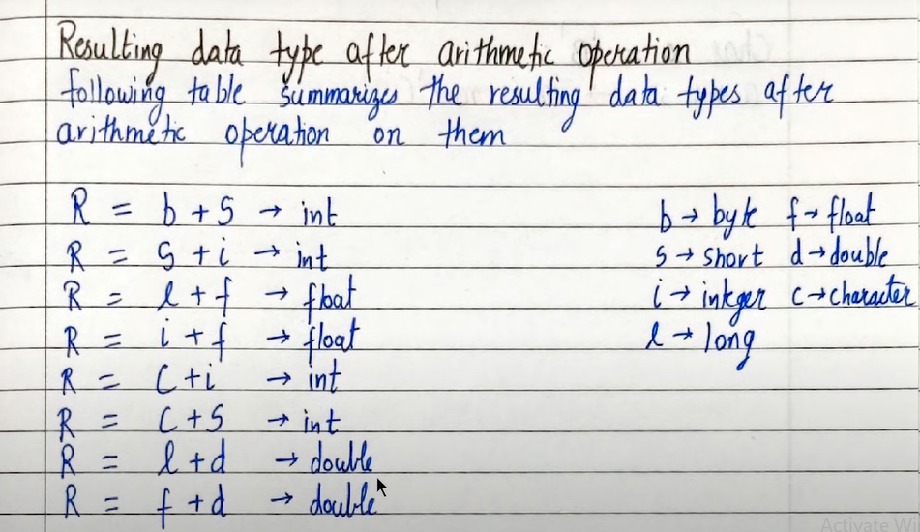

Increment and decrement operators don’t work on boolean variables.

// Error- float g= 3/4.0; Possible lossy conversion from double to float

- float g= 3/4;
System.out.println(g); // 0.0

- System.out.println(3/4.0); // 0.75

- float a= 3f;
float b= 4f;
float c=a/b; // 0.75
System.out.println(c);

String is a class.
String s = new String(“Hello”);

But it can also be used as data type
String st= “Swarali !”;

int a =3;
float b = 5.68f;
System.out.printf(“values of a and b are: %d and %f”, a , b);
System.out.format(“values of a and b are: %d and %f”, a , b);

%.2f prints only 2 decimals from after the decimal point.
(5.6789 => 5.67 would be printed)

float ft= 6.31458f;
System.out.printf("ft is %.2f \n", ft); // ft is 6.31
System.out.printf("ft is %8.2f", ft ); // ft is 6.31 // 4 spaces + 4 (6, . , 3, 1) = 8

Strings are immutable and cannot be changed in Java.

length() , toLowerCase(), toUpperCase() ,
trim() -> (eliminates leading and trailing spaces)

String str= “GeeksForGeeks2022”
str.substring(7); // string from 7th index of str till last index
str.substring(7,10); // string from 7th index of str till 10th index

// Every occurrence of old character or old string will be replace by new character or string
str.replace(‘old_character’ , ‘new_character’);
// new string with old character replaced by new character will be returned
str.replace(“old_target ” , “new_target”);

String s="Swarali_Joglekar";
System.out.println(s.startsWith("Swar")); // true boolean result
System.out.println(s.endsWith("ali")); // false

System.out.println(s.charAt(3)); // character at given index
System.out.println(s.indexOf("Jog")); // returns index of the given string (answer= 8)
System.out.println(s.indexOf("Jog", 9)); // starting from 9th index (answer= -1)

String stri= "Harryrry";
System.out.println(stri.lastIndexOf("rry")); // 5
System.out.println(stri.lastIndexOf("rry", 4)); // 2
lastIndexOf() starts searching from end of the string

String swa= "Swarali";
System.out.println(swa.equals("Swarali")); // true
System.out.println(swa. equals("swarali")); // false
System.out.println(swa.equalsIgnoreCase("sWaRali")); // true

int [ ] marks; // declaration
marks= new int[ 5 ]; // memory allocation

int [ ] marks= new int[ 5 ]; // declaration + memory allocation

int [ ] marks= { 5, 6, 8, 9, 15}; // declaration + initialization

array_name.length -> length of array

int [ ] marks2 = {1, 2, 3, 4, 5 };
for( int element: marks2){ // for each loop
System.out.println(element) ;
}

int [][] flats;
flats= new int [2][3];

for(int i=0; i< flats.length; i++){
for(int j=0; j< flats[i].length; j++){
System.out.print(flats[i][j] + " ");
}
System.out.printf("\n");
}

Integer.MAX_VALUE - max integer value in java
Integer.MIN_VALUE - min integer value in java

Practice question- Check whether an array is sorted or not
if arr[i] > arr[i +1]{
flag=1;
break;
}

static method in a class is shared by all objects.
static method is used to associate a method of a given class with the class, rather than the object.

When an array is passed to a method, its reference is passed. So, changes made in the called function are reflected in the calling function as well.

Arguments are actual.
Parameters are inside the function.

Method overloading cannot be performed by changing the return type of methods.

static void foo() {}
static int foo() {} // these 2 will be considered as same methods
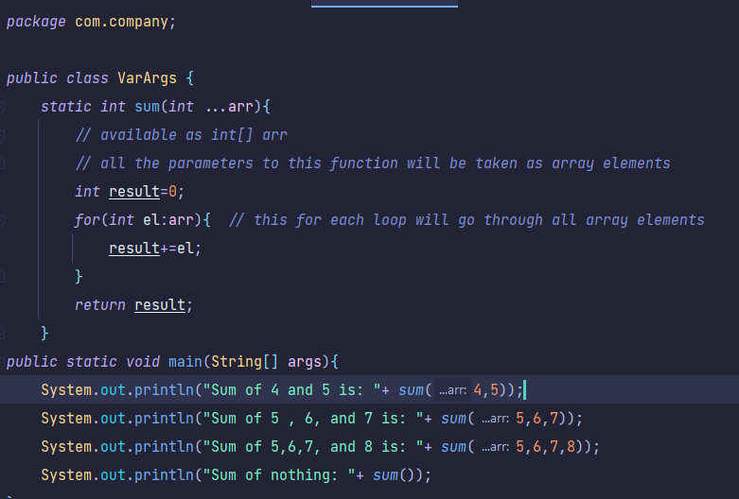

Variable arguments (Varargs)
See the image above.
We can pass any number of arguments to the function, because those arguments will be taken as array elements using int …arr
In the last line, we didn’t pass anything to the function, but it was not the error.
But if we write sum(int x, int …arr) , then x becomes a compulsory argument.
i.e. it makes at least one integer a compulsory argument.

One file can have only one public class in java.

import java.util.Random;
Random random = new Random();
int computerInput = random.nextInt(3);

Constructors can be overloaded just like other methods in java.

Math.PI // use whenever pi value will be needed

Inheritance-
class Derived extends Base

When the derived class is extended from the base class, the constructor of the base class is executed first, followed by the constructor of the derived class.

super(a,b); // calls the constructor from the parent class which takes 2 variables

this is a way for us to reference an object of the class which is being created or referenced.

Dynamic method dispatch
Phone obj = new Smartphone();
// obj has a reference to superclass but it’s an object of subclass.
// obj can’t call methods of subclass except the common methods in both classes.
// obj can call all methods of superclass except the common methods of classes.

Abstract class
abstract class Base2{
public Base2(){
System.out.println("constructor of base2 class");
}
abstract public void greet();

We can also assign reference of abstract class to the object of a concrete subclass.

Interface
In Java, an interface is a group of methods with empty bodies.

interface Bicycle{
void applyBrakes(int decrement){};

}

class Herocycle implements Bicycle{
int speed=7;
public void applyBrakes(int decrement){
speed=speed-decrement;
}
}

We cannot extend multiple abstract classes, but we can implement multiple interfaces at a time.

Methods of interface which are implemented by class, should be public in the class.

You cannot modify the properties in the interface as they are final (constant).

class heroCycles implements Bicycle, Horn{ // syntax for implementing two interfaces
}

Multiple inheritance is not allowed in Java.

A class can implement multiple interfaces and extend a class at the same time.
Interfaces can only have method signatures, constant fields and default methods.
The class implementing an interface needs to declare the methods, but not necessarily the fields.
You can create a reference of interfaces but not the object.

Default methods enable us to add new functionality to the existing interface. This feature was introduced in Java & to ensure backward compatibility while updating an interface.

interface childInterface extends parentInterface

class sampleClass implements childInterface

// Interface cannot implement another interface

Interpreter- Partial execution if error
Compiler- No execution if error
Interpreter is needed every time.
Once compiled, a compiler is not needed.
Compiled languages are faster than interpreted ones.
Interpreted languages are easy for programmers.

Java is a hybrid language(both interpreted and compiled)

Package- is used to group related classes
Packages help in avoiding name conflict.
Built in packages -> Java API (e.g. java.util.Scanner)
User defined packages -> Custom packages

import java.util.* - all packages inside java.util

java.util.Scanner sc= new java.util.Scanner(System.in); // without importing
int a = sc.nextInt();

javac -d . Harry.java - to create package folder // for visual studio
But package has to be mentioned in the program

package harry.gym -> gym folder inside harry folder

